PROJECT 1

PROJECT TITLE: RETAIL PROFIT ANALYSIS FOR DIFFERENT REGIONS AND CATEGORIES FOR EACH YEAR (3 YEARS)
TOOLS USED : MICROSOFT EXCEL & POWER BI
DATE: 01-DECEMBER-2025
PROJECT OVERVIEW
-A retail sales dataset for a particular firm(Royal Touch ) was provided for different categories for a period of 3 years .There are 6 categories which are Beauty ,Clothing , Electronics , Footwear , Groceries and Home Appliances .This was a period of the years 2021 to 2023 .
-The main aim of the project was to the profit which was obtained in each category for each year for all the categories and all the years .
-This will aid in determining which category was profitable for a certain year and thus to be done for all the categories and all the years .
METHODOLOGY
-The data was mixed with the categories not grouped as well as the period of transactions. It also contained the sales and cost of costs of goods sold of which these were not relevant to the report .
-Therefore through the use of data cleaning methods such as filters I was able to discriminate so as to get the data for each category and each transactional year for each region .
-I then moved to calculate the sum of profit for each category , for each region and each year which allowed me to summarize the data in excel and use for the visualizations in power bi .
-The visualizations contain a details of profits obtained for each region by category and year

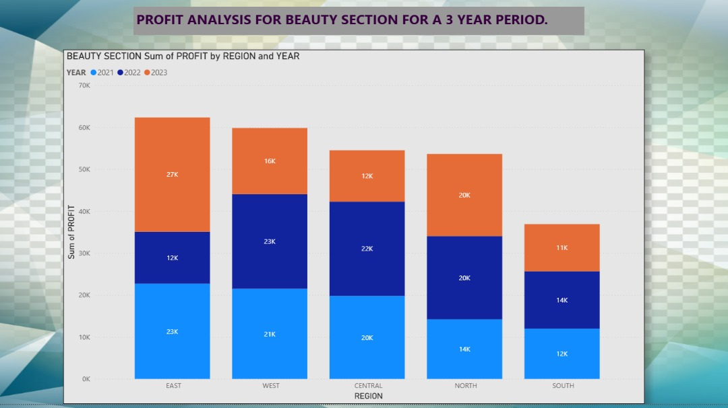

Overall performance:
The Beauty section shows strong but uneven profitability across regions over the three-year period (2021–2023). Total profits generally vary by region more than by year.
• By Region:
- East is the highest-performing region overall, recording the largest combined profits across the three years, with a particularly strong contribution in 2023.
- West follows closely, showing consistently high profits, especially strong in 2022.
- Central maintains moderate and stable profits, with a slight decline in 2023 compared to earlier years.
- North shows balanced contributions across the three years, with profits peaking around 2022–2023.
- South records the lowest total profits, though it still shows steady performance without extreme fluctuations.

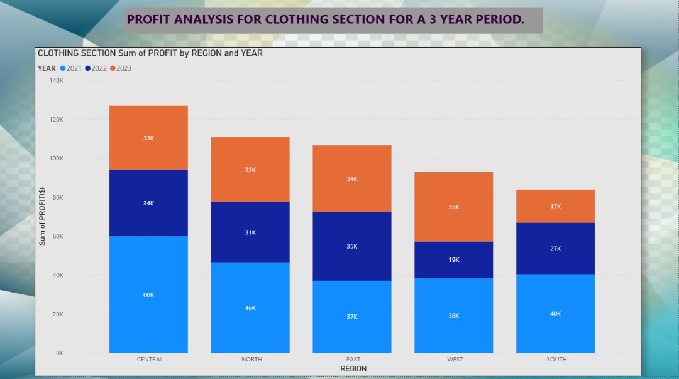

Overall performance:
The Clothing section shows higher overall profitability than the Beauty section, with strong contributions from all regions over the three-year period (2021–2023).
• By Region:
- Central region is the top-performing region, recording the highest total profit across the three years, driven especially by a very strong 2021 performance.
- North and East regions also show high and fairly balanced profits, indicating stable demand and consistent sales.
- West region records moderate profits, with noticeable growth in 2023.
- South region has the lowest total profit, though it maintains steady contributions, particularly in 2021 and 2022.
• By Year (Category):
- 2021 (light blue) is the strongest year overall, contributing the largest share of profits across almost all regions.
- 2022 (dark blue) shows a slight decline compared to 2021, but remains stable, especially in Central and East.
- 2023 (orange) demonstrates mixed results—strong growth in West and East, but relatively lower performance in South.
• Key Insight:
Clothing profits are driven mainly by strong regional performance in Central, North, and East, with 2021 as the peak year. Later years show some redistribution of profits across regions rather than uniform growth.

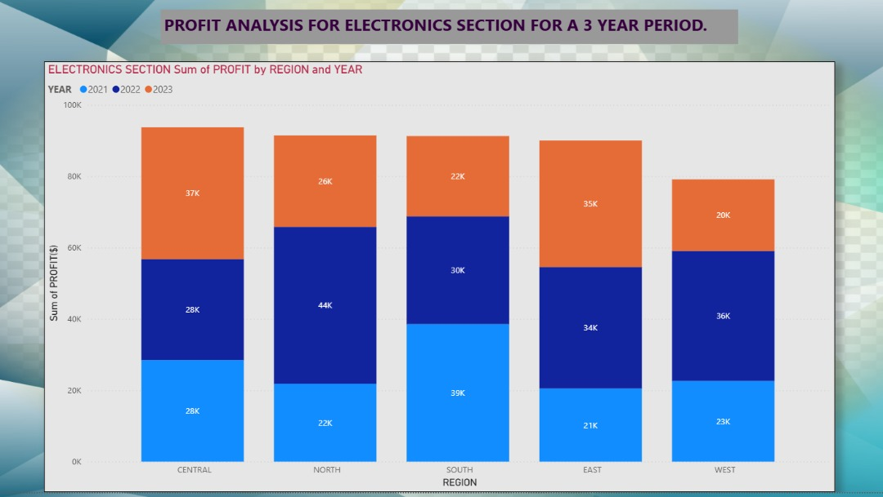
Overall performance:
The Electronics section shows strong and fairly balanced profitability across regions, with noticeable year-to-year variation, especially between 2022 and 2023.
• By Region:
- Central region records one of the highest total profits, driven mainly by strong performance in 2023.
- North region performs consistently well, with 2022 contributing the largest share of its profits.
- South region stands out for its very strong 2021 performance, making it a key contributor overall.
- East region shows steady profits, with a significant increase in 2023.
- West region maintains moderate but stable profits, led by a strong 2022 result.
• By Year (Category):
- 2021 (light blue) shows strong profits in South and Central, indicating a solid starting year.
- 2022 (dark blue) is the most consistently strong year across most regions, particularly North and West.
- 2023 (orange) shows growth in Central and East, but relatively lower contributions in South and West.
• Key Insight:
Electronics profits are well distributed across regions, with 2022 emerging as the most stable and reliable year, while 2023 shows region-specific growth opportunities, especially in Central and East.

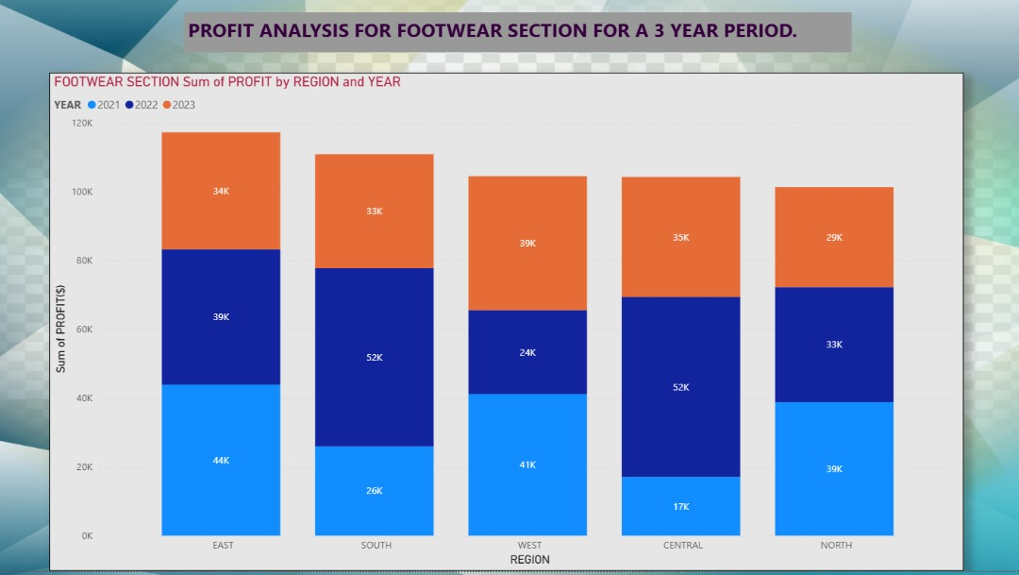
Overall performance:
The Footwear section demonstrates strong and fairly consistent profitability across all regions over the three-year period, with no extreme declines in any year.
• By Region:
- East region records the highest overall profit, driven by strong results in both 2021 and 2022.
- South region also performs very well, with 2022 being its strongest year.
- Central region shows balanced profits, with a significant peak in 2022.
- West region maintains stable performance, with a noticeable increase in 2023.
- North region shows steady and well-distributed profits across the three years.
• By Year (Category):
- 2021 (light blue) contributes strongly in East, West, and North, indicating a solid base year.
- 2022 (dark blue) is the dominant year for Footwear, producing the highest profits in most regions, especially Central and South.
- 2023 (orange) remains competitive, showing improvement in West and maintaining solid contributions in all regions.
• Key Insight:
Footwear profits are regionally diversified and year-balanced, with 2022 emerging as the peak performance year and East and South acting as major profit drivers.

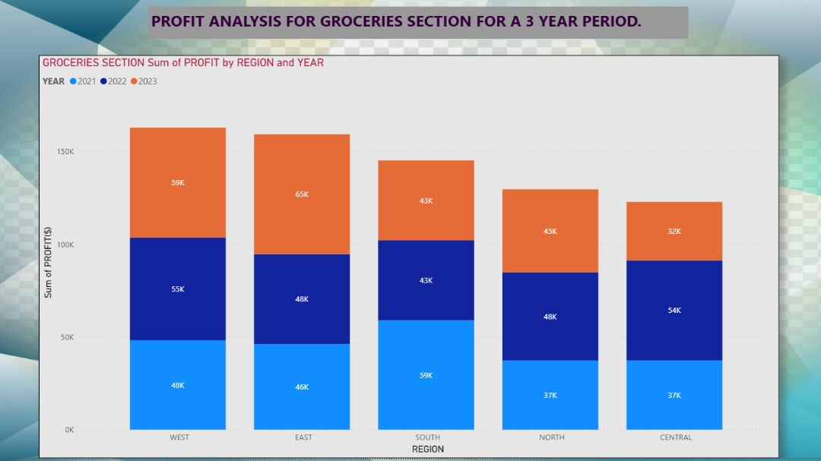
Overall performance:
The Groceries section is the highest profit–generating category among all sections, showing very strong and consistent profits across all regions over the three-year period.
• By Region:
- West region records the highest total profit, driven by strong performance in all three years.
- East region follows closely, with 2023 being its strongest year.
- South region shows balanced and stable profits, with a notable peak in 2021.
- North region maintains moderate but steady profitability, with improvements in 2022 and 2023.
- Central region has the lowest total profit, though it still shows solid and consistent contributions.
• By Year (Category):
- 2021 (light blue) provides a strong base year, especially in South and West.
- 2022 (dark blue) is the most consistently strong year, contributing significantly across all regions.
- 2023 (orange) shows mixed performance—very strong in East and West, but relatively lower in Central.
• Key Insight:
Groceries profits are high-volume and stable, with West and East acting as core profit centers, and 2022 emerging as the most reliable year overall.

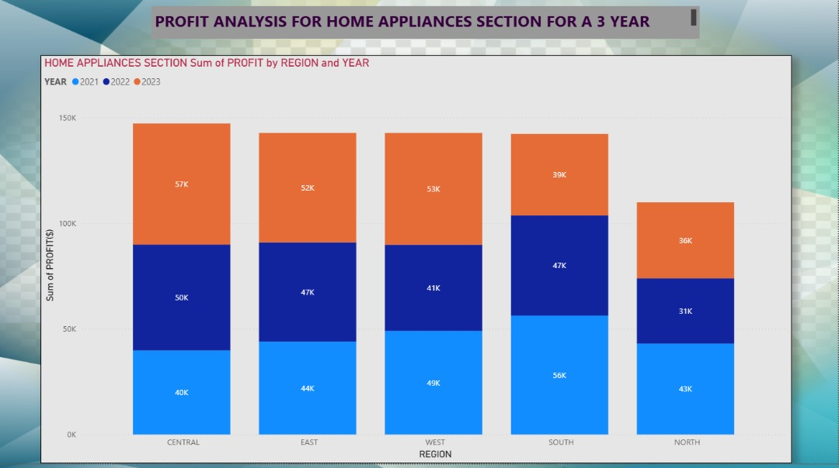

Overall performance:
The Home Appliances section shows strong and consistent profitability across all regions, with relatively high profit levels maintained throughout the three-year period (2021–2023).
• By Region:
- Central region records the highest overall profit, driven mainly by a strong performance in 2023.
- East and West regions follow closely, both showing balanced and stable profits across all three years.
- South region performs well, with 2021 contributing the largest share of its total profit.
- North region has the lowest total profit, though it still maintains steady year-on-year contributions.
• By Year (Category):
- 2021 (light blue) shows strong contributions in South and West, indicating a solid starting year.
- 2022 (dark blue) remains stable across all regions without major spikes or declines.
- 2023 (orange) is a key growth year, especially in Central, East, and West regions.
• Key Insight:
Home Appliances profits are well-distributed and resilient, with no heavy dependence on a single region or year, making it one of the more stable sections overall.

CONCLUSION

Profit Performance Across Six Sections (2021–2023)
The analysis of profits across the six product sections over a three-year period reveals clear differences in performance by region and year, highlighting both high-volume categories and specialized growth areas. Overall, Groceries, Home Appliances, and Clothing emerge as the strongest contributors to total profit, while Beauty and Electronics show more region-specific strengths.

1. Best Performing Sections by Year

2021
- Top Section Overall: Groceries
  - Dominated profits in West and South, reflecting strong consumer demand for essential goods.
- Strong Contributors:
  - Clothing (Central, North)
  - Footwear (East, West)
- Insight:
2021 profits were driven largely by necessity-based products, especially groceries and basic apparel.

2022
- Top Section Overall: Footwear
  - Achieved peak profits in Central and South.
- Consistently Strong Sections:
  - Groceries (all regions)
  - Electronics (North and West)
- Insight:
2022 was the most balanced year, with multiple sections performing well across most regions, indicating market recovery and consumer confidence.

2023
- Top Section Overall: Home Appliances
  - Led profits in Central, East, and West.
- Other Strong Performers:
  - Groceries (West, East)
  - Beauty (East, North)
- Insight:
Consumer spending shifted toward durable and lifestyle-enhancing goods, reflecting improved purchasing power.

2. Best Performing Sections by Region

Central Region
- Best Overall Section: Home Appliances
- Supporting Sections: Clothing, Footwear
- Trend:
Strong and stable profits across all three years, with appliances leading growth in 2023.

East Region
- Best Overall Section: Groceries
- Strong Alternatives: Beauty, Footwear, Home Appliances
- Trend:
East is a high-volume and diversified market, showing strong growth in both essentials and discretionary products.

West Region
- Best Overall Section: Groceries
- Other Strong Sections: Clothing, Electronics, Home Appliances
- Trend:
West is the most profitable region overall, driven by consistent demand across all years.

North Region
- Best Overall Section: Clothing
- Supporting Sections: Electronics, Groceries
- Trend:
North shows steady but moderate growth, favoring apparel and technology-related products.

South Region
- Best Overall Section: Footwear
- Other Strong Sections: Groceries, Electronics
- Trend:
South displays strong demand for fashion and personal goods, particularly in 2022.

3. Comparative Performance of Sections
Section | Overall Performance | Key Strength
Groceries | ⭐⭐⭐⭐⭐ (Highest) | Consistent, high-volume profits
Home Appliances | ⭐⭐⭐⭐½ | Strong growth, especially in 2023
Clothing | ⭐⭐⭐⭐ | Stable regional demand
Footwear | ⭐⭐⭐⭐ | Peak performance in 2022
Electronics | ⭐⭐⭐½ | Region-specific strength
Beauty | ⭐⭐⭐ | Lifestyle-driven growth

4. Strategic Business Implications
- Prioritize Groceries as the core revenue driver, especially in West and East.
- Expand Home Appliances aggressively in Central, East, and West regions.
- Target Footwear and Clothing promotions in South and North respectively.
- Adopt region-specific strategies for Electronics and Beauty to maximize niche demand.
- Leverage 2022 patterns as a benchmark for balanced growth planning.

Final Business Conclusion
The business demonstrates a well-diversified product portfolio, with Groceries providing stability, Home Appliances driving recent growth, and Clothing and Footwear offering strong regional opportunities. A data-driven regional focus combined with category-specific strategies will enable sustained profitability and optimized market expansion.

